# Git Practice

1. Go to <https://github.com/lync0143/git-practice/>
2. Click on Fork.

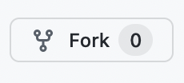

1. Get the address of your fork by clicking the green button labeled Code and clicking the two overlapping squares to copy the address to the clipboard.

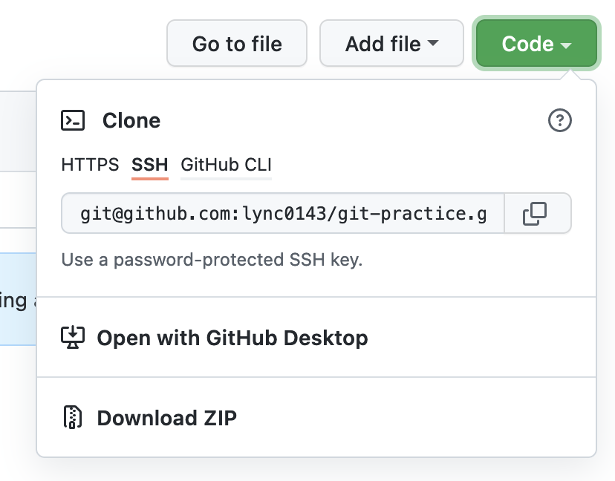

1. From a command line prompt, clone the repository:

git clone git@github.com:lync0143/git-practice.git

Note: the address will be different from what is listed here.

Now you are ready to begin branching and committing!

When you need to create a new branch, remember these steps:

1. Checkout
2. Pull
3. Checkout
4. Add
5. Commit
6. Push

To incorporate a branch’s changes into the reference branch:

1. On GitHub, click on **Pull requests**, then click the green button labeled **New pull request**.
2. You will see two buttons:
   1. Base – the reference branch, into which changes will be merged
   2. Compare – the branch containing new changes

Select the branches and then click on the green button labeled **Create pull request**.

1. You will be prompted to add a title and description for the pull request. Click on the green button labeled **Create pull request**.
2. Click on the green button labeled **Merge pull request**.